PHOTOGRAPHS AND VIDEOS
Your wedding is an act of sacred worship. In order to maintain the sanctity of this time, flash photography is not permitted during the service.

If you are hiring a photographer, please ensure that they are discreet about their movements, and that they introduce themselves to the clergy well before the service. If a video is to be used, please speak with the officiating priest about its use and placement. Videographers are encouraged to use a fixed tripod and set up their equipment 30 minutes before the service, and are not permitted to use special lighting.
Guests are encouraged to limit photography to when the couple is entering and leaving the service (the procession and recession), and during the signing of the Register.

HOW MUCH DOES IT COST?
Whether you are celebrating the blessing of your marriage at St. Hilary’s or at another site, there is time invested in preparing for this celebration. These are not set fees, but suggested guidelines for you to consider:
- Church Fee: This will contribute to the ongoing expenses of operating the ministry of St. Hilary’s to you and to others in the community. $200
- Clergy Honorarium: For the time the clergy provides in meeting with you and co-ordinating the rehearsal. --$300.00 If the celebration of your wedding is not at St. Hilary’s please consider the cost of transportation and accommodation for the clergy if that is required.
- Chancel Guild: These volunteers prepare the church for your celebration. Your Fee supports the purchase of linens, candles or flowers for special occasions and worship.
“St. Hilary’s Chancel Guild” -- $100.00
- Music: If you are employing the services of our resident Music Director to play the organ or piano for your service:- $250.00

Income tax receipts available for any general donation.

EVEN BEFORE YOU SET THE DATE……

Something great has already been happening.
Whether you have been getting to know one another over a period of weeks, months or years, somehow you have begun to realise that you are being called to be married to one another. "Isn’t it amazing that I have been given this person to love and that they are saying the same thing about me!"

Once you have begun to consider this call, the clergy and people of St. Hilary’s Church are ready to help and support you and we would like to offer that support as soon as possible. Many couples and individuals have appreciated having someone to listen to their questions and dreams and our clergy would be pleased to be such a person for you. Arranging to see the Priest need not be a statement of a finished decision. We would simply like to be a resource to you as you make a commitment to one another.

At what point should we “book the priest?”
Once you choose to give yourself to one another in a lifelong commitment in marriage then it is very appropriate to share your intentions with a priest and begin discussing your future plans. It is ironic that the kind of party most people choose to have following the wedding ceremony actually requires more advance booking time than the wedding itself. Nevertheless, it is always advisable to make an appointment to speak with our priest before making any reception hall bookings.
A personal interview will be the first step in the relationship
between a couple and the priest who may be celebrating your
wedding with you. We prefer to meet in person with couples
at least six months before the proposed date of your wedding.
This gives us time to focus on preparing for your marriage as
well as celebrating your wedding.

Who can be married by the clergy from St. Hilary’s?
A Christian marriage is celebrated when at least one of the
couple is a baptised in a Christian Church and both people desire to celebrate their commitment before God. Should either or both of you have been previously married, and should either or both previous spouse(s) still be living, it will be necessary for us to work together to ensure that responsibilities to a previous spouse and any children from a previous marriage are well taken care of. It would also be necessary for the priest to see an authenticated copy of a Decree Absolute.

ENRICHING YOUR MARRIAGE
While we take the details of planning the celebration of your
marriage very seriously, our primary focus is on assisting you
to prepare for your married life together. Some of our
assistance will be offered in informal meetings over the months
of your preparation. This also assures that the officiating priest
will not be a "stranger" at your wedding.

We require that every couple participate in a marriage preparation course before your wedding date. Two resources that we recommend are:

“Prepare and Enrich” is an excellent resource for couples of any age. It requires an online questionnaire which is followed by an Enrich Facilitator. www.enrichcanada.ca

“Marriage Prep” facilitated by Brian Murray who is an Anglican priest and a Marriage and Family Therapist. www.marriageprep.com

WHAT ABOUT A MARRIAGE LICENCE? Couples seeking to be married in the Province of Ontario must obtain a license from a municipal office anywhere in the Province. The license is effective for 90 days. We require a valid license be obtained and brought in to the parish office no later than two weeks prior to the proposed wedding date.

.

THE SERVICE

LOCATION
Under certain circumstances some couples request permission to celebrate and bless their marriage at a location other than St. Hilary’s Church. If you are thinking of that option, the clergy needs to ask the bishop’s permission for officiating at a service outside of the church. It needs to be understood that we still need to use the liturgy for the “Blessing and Celebration of Marriage” according to the Book of Alternative Services in the Anglican Church of Canada. Every effort must be ensured to maintain the reverence and decorum of a service of worship, and the physical location of the service is required to be separate from the place for the reception; and if the service is outside, please consider a rain option!

MUSIC
Music has always played a significant role in Christian worship. Naturally, the music chosen for such a joyful occasion as a Christian marriage should be appropriate to this service. If the service is at St. Hilary’s, please contact the Music Director. The number is on the back of this brochure.

READINGS AND PRAYERS OF THE PEOPLE
These are appropriate times for family members or friends to
be involved in the liturgy. Texts for readings can be discussed with the clergy, and are primarily found in the Holy Scriptures of the Christian church.

FLOWERS
If the service is held at St. Hilary’s please contact the flower convener about what arrangements you intend to make regarding flowers and decor. The number is on the back of this brochure.

MOBILE DEVICES – please turn these off during the service.

St Hilary’s Anglican Church

2055 Hurontario Street,

Mississauga, ON, L5A 2E6
sthilarycooksville@toronto.anglican.ca

www.sthilarys.com

905-279-2304

Incumbent
The Rev’d Adrienne Clements 905-279-2304
adrienne.clements987@gmail.com

Parish Administrator
Barb Finlay 905-279-2304
contact@sthilarys.com

Flower Convenor
Pat Brown 905-279-9534

Music Director
Keith Scott 905-279-2304

Sunday Services
8:30 Holy Communion
10:30 Choral Eucharist

Planning for the
Celebration and Blessing
of your Marriage

with

St. Hilary’s, Cooksville

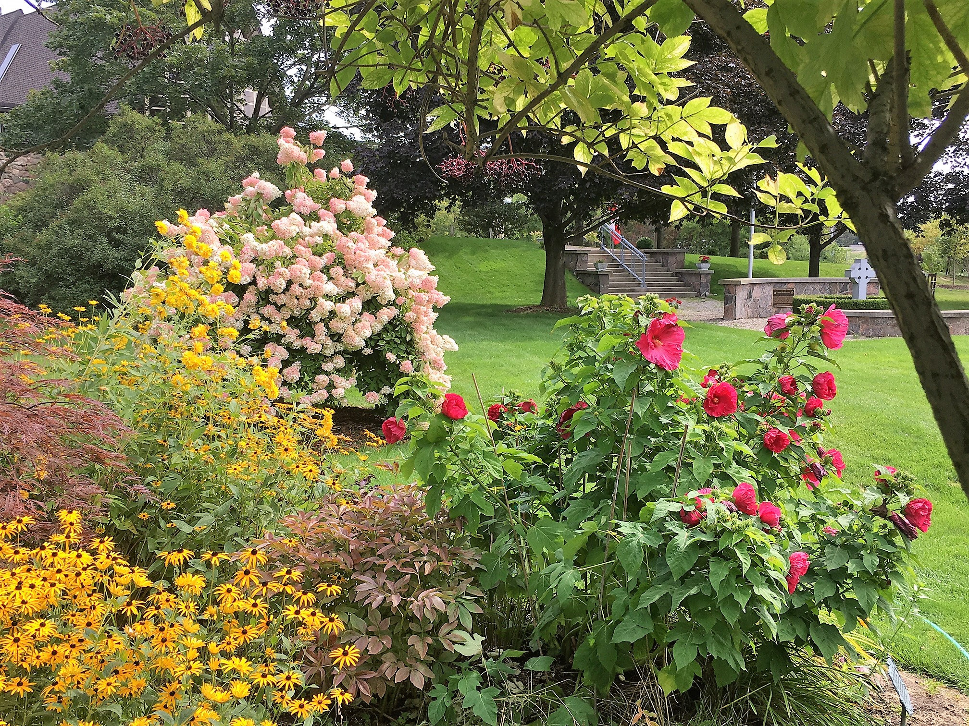

Revised: February, 2020

Thank you for choosing St. Hilary’s

It is an honour to work with you as you prepare for your married life together. I trust that as you grow together in your commitment to one another you may also grow deeper into an awareness of who you are and what is important to you.

This is an exciting journey of discovery and learning that you embarking on. In working with you at this point of your journey I hope that you will find a place to address your questions and grow in your sense of self.

May God continue to bless you.

Faithfully,

The Rev’d Adrienne Clements
Priest-in-Charge of St. Hilary’s

If you have any further questions or concerns
at any point in your preparation,
please do not hesitate to contact us.
Contact information is available on the back of this brochure.

