The Service and Funeral Home

The staff and clergy of St. Hilary’s will work with the funeral home to make sure that all the details of planning such as arrival and service time and flower delivery are accomplished effectively and with dignity.

The Church and Catering

If you wish to have a reception in the church after the service, St. Hilary’s is happy to recommend caterers that are reasonable and who offer quality service.

You may wish to arrange your own catering or the church may be able to assist with getting food items. Families may choose any of these options.

The Funeral and Finances

A funeral is a ministry of the church and so fees are kept to a minimum as far as possible. We are glad to help families during this difficult time.

However, in recognition that funerals demand considerable time and effort by both staff and volunteers, fees are necessary and gifts are welcome and appropriate.

Fees:

Organist $225
Soloist (if desired) tbd
Videographer $100
Altar Guild $100
Church Hall & Kitchen $150
Church Fee $350
Clergy $350

Gifts:

St. Hilary’s At your discretion
You may wish to memorialize your loved one with a gift to St. Hilary’s. It is possible to designate the gift for a special project or to the general operations of the church.

St. Hilary’s Anglican Church

2055 Hurontario Street
Mississauga, ON L5A 2E6
Phone: 905-279-2304
Email: sthilarycooksville@toronto.anglican.ca
Rev. Adrienne Clements
Email: Adrienne.clements987@gmail.com

St. Hilary’s Anglican Church

A Guide to Funerals
At
St. Hilary’s

The death of a loved one is always a difficult and deeply stressful time. At St. Hilary’s, we are dedicated to helping you with this important but often challenging task of planning a funeral.

Our desire is to guide you through the process of funeral planning so that the service might be a source of comfort and peace to all who attend.

St. Hilary’s and Funerals

St. Hilary’s offers a variety of services for those who have suffered a loss through death…

The Funeral Service

St Hilary’s is available to host a funeral service for a loved one who has died. The Clergy of St. Hilary’s are available to help you plan the service and the details that surround it.

Spiritual Comfort

The clergy are ready to offer spiritual comfort and direction based on Scripture and the traditions of the church. They are also happy to provide support and prayer for you as you go through this time. Contact with the clergy does not have to be restricted to the time around the funeral: they are always ready to help.

Grief Counselling

While the clergy are skilled professionals, they are not trained as grief counsellors. However, if your grief has become debilitating, the clergy can refer you to competent professional grief counsellors with whom they have worked in the past.

The Clergy and the Service

When the Church is requested to host a funeral, the clergy will meet with the family to offer comfort in the midst of grief and to guide them through the details of the service.

The clergy will seek not to impose an arbitrary, unvarying service but will work with the family to help them craft a service that suits their needs.

While there are many opportunities for family choice, there is a central unifying form to the service. The liturgy, which can be found in the Anglican Prayer Books, is the central core of the service. The clergy will be happy to show you a copy.

The Family and the Service

There are opportunities for family involvement in the service. If they wish, family members may choose the Scripture readings and hymns. Friends and family can read the lessons from the Scripture, lead in prayer and give eulogies. Some families may wish to be involved, others desire to leave such details to the clergy.

At every point in the planning, the clergy will offer counsel to assist the family in making meaningful choices .

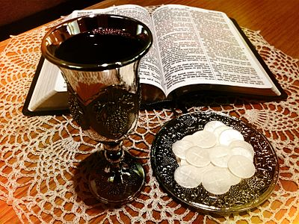

For those who choose, the celebration of Holy Communion can be part of the service.

